2022 IABC World Conference
Volunteer Marketing Kit

About this Marketing Kit
As an IABC volunteer, you are in a unique position to promote the 2022 IABC World Conference and help make the experience a success. We know that you’re eager to spread the word about the conference, so we’ve created this marketing kit to help you share your excitement.

To support our outreach efforts, we ask you do any or all of the following:

- ENCOURAGE ATTENDANCE – Send an email to your co-workers and colleagues using the template below.
- PROMOTE THROUGH YOUR ORGANIZATION – Add the 2022 IABC World Conference to your organizational and work calendars, newsletters and digital bulletin boards using the template below.
- LIKE, RETWEET AND USE THE #IABC22 HASHTAG – Encourage attendance and spread awareness of the 2022 IABC World Conference.

Conference Details
Included below are important conference details that you may reference and use when spreading the word about the 2022 IABC World Conference.

Dates
26–29 June 2022

Location
New York City, New York, USA

Website
https://wc.iabc.com/

Social Media Hashtag
#IABC22

Social Media Channels
Facebook https://www.facebook.com/IABCWorld
Twitter
https://twitter.com/iabc
YouTube https://www.youtube.com/user/IABClive
LinkedIn https://www.linkedin.com/company/iabc/
Instagram
https://www.instagram.com/iabcgram/

Sample Email Communication
The following message was developed for your ease of use; copy and paste, or modify the message to send via personal email to your network of coworkers, colleagues and professional contacts.

Subject: Help Lead the Change at the 2022 IABC World Conference

Dear [Contact Name],

IABC continues to adapt and lead the change within the communications field. That’s why I’m thrilled to share that the 2022 IABC World Conference is returning (in person!) this June.

As a volunteer, I know that IABC is focused on professional development and advancement of the communications field. I’m looking forward to a tailored program filled with the topics you care about. I hope you’ll take advantage of this additional opportunity to make connections and share new ideas.

The 2022 Conference theme is all about the many achievements that communication can help accomplish. We’ll discuss how communication can lead, transform, inspire, and more. Plus, being in-person means:

- Additional sessions to choose from
- More opportunities to connect and expand your network
- The chance to explore the Big Apple with your peers
- Face-to-face interaction in the Exhibit Hall
- And more!

I look forward to joining IABC 26-29 June in New York City for this exceptional event, and I hope you will be a part of it.

Make sure that you secure your registration so that we can connect this June.

Sincerely,
[Your Name]

Sample Social Media Posts
Use these customizable social media posts to share the 2022 IABC World Conference with your personal and professional network. Don’t forget to use #IABC22 and tag IABC when you post!

Sample One
Join me 26–29 June for #IABC22 to network, learn and explore with dozens of global speakers and thousands of fellow #comms professionals. Register here: https://wc.iabc.com/.

Sample Two
Communication can… change. Lead. Inspire. Challenge. See what else it can do at #IABC22 this June in New York City! Register to attend as we all look to rejoin and reconnect in one spot. Will I see you there? https://wc.iabc.com/

Sample Three
I am so excited to be support IABC at the 2022 World Conference, happening 26–29 June! With dozens of global speakers and access to a network of thousands of #comms professionals, you won’t want to miss this. Register here: www.wc.iabc.com #IABC22

Sample Four
It’s time to finally reconnect with your global communications family. #IABC22 will help you grow your network along with your professional skills, while advancing the #comms profession. Learn more and register to join me in New York 26–29 June: https://wc.iabc.com/.

Calendar, Newsletter and Bulletin Board Event Description
Use this event description to share via calendar event, newsletter or digital bulletin board.

2022 IABC World Conference
The 2022 IABC World Conference is back in-person. For the first time in three years, we will join together for learning and networking, this time in New York City! We want to highlight the many feats of communication, from inspiring others to leading change. Join us 26–29 June.

With dozens of global speakers covering today’s pressing topics, you can expect a diverse education experience from experts who are second to none in their field.

Plus, while enhancing your communications skillset, you can also develop professionally by networking and forming connections with other attendees and companies.

Learn more and register today at https://wc.iabc.com/.

Email Signature
Add the below copy and graphic to your email signature to help spread the word of the conference. Don’t forget to hyperlink the image.

Join me at the 2022 IABC World Conference, happening in New York City, 26-29 June!

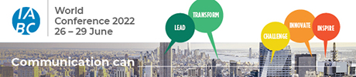

Event Graphics
Save the below graphics to help promote the conference in emails or on social media.

SOCIAL:
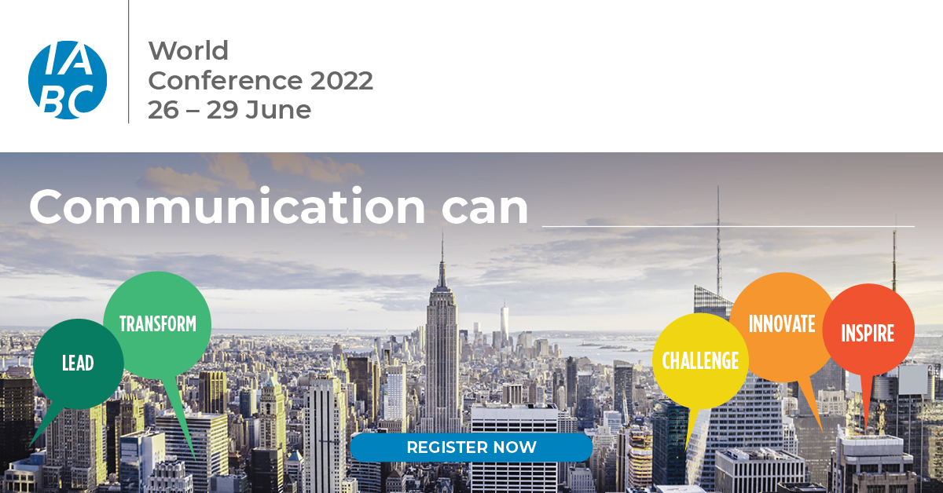

EMAIL:

