2023 IABC World Conference
Speaker Marketing Kit

About this Marketing Kit
As a speaker of the 2023 IABC World Conference, we know that you’re eager to spread the word about the conference’s offerings and experiences. We’ve created this marketing kit to help you share your excitement about the conference.

To support our outreach efforts, we ask you do any or all of the following:

- ENCOURAGE ATTENDANCE – Send an email to your co-workers and colleagues using the template below.
- PROMOTE THROUGH YOUR ORGANIZATION – Add the 2023 IABC World Conference to your organizational and work calendars, newsletters and digital bulletin boards using the template below.
- LIKE, RETWEET AND USE THE #IABC23 HASHTAG – Encourage attendance and spread awareness of the 2023 IABC World Conference.

Conference Details
Included below are important conference details that you may reference and use when spreading the word about the 2023 IABC World Conference.

Dates
4-7 June 2023

Location
Toronto, Ontario, Canada

Website
https://wc.iabc.com/

Social Media Hashtag
#IABC23

Social Media Channels
Facebook https://www.facebook.com/IABCWorld
Twitter
https://twitter.com/iabc
YouTube https://www.youtube.com/user/IABClive
LinkedIn https://www.linkedin.com/company/iabc/
Instagram
https://www.instagram.com/iabcgram/

Sample Email Communication
The following message was developed for your ease of use; copy and paste, or modify the message to send via personal email to your network of coworkers, colleagues and professional contacts.

Subject: Join My Session at the 2023 IABC World Conference

Dear [Contact Name],

IABC continues to shake things up within the communications field. That’s why I’m thrilled to be speaking at the 2023 IABC World Conference this June.

My session will focus on [insert topic]. I can’t wait to discuss [insert discussion points] at the conference in Toronto.

This year, we are looking forward to a unique program filled with dialogue-focused experiences and new session formats – plus, curated sessions focused around the different stages of IABC Career Paths. I hope you’ll take advantage of these opportunities to make connections and share new ideas.

The 2023 Conference theme is all about showcasing the way communication can deepen: relationships, impact, curiosity, and so much more. I look forward to joining IABC 4-7 June in Toronto for this exceptional event, and I hope you will be a part of it.

Make sure that you secure your registration so that we can connect this June.

Sincerely,
[Your Name]

Sample Social Media Posts
Use these customizable social media posts to share the 2023 IABC World Conference with your personal and professional network. Don’t forget to use #IABC23 and tag IABC when you post!

Sample One
Join me 4-7 June for #IABC23 to network, learn and explore with dozens of global speakers and hundreds of fellow #comms professionals. Register here: https://wc.iabc.com/.

Sample Two
Communication can deepen: relationships, purpose, impact, curiosity. Come see how your communication can have a tremendous effect on those around you at #IABC23 this June in Toronto! Register to attend as we all come together to learn. Will I see you there? https://wc.iabc.com/

Sample Three
I am so excited to be speaking at #IABC23, happening 4-7 June! With dozens of global speakers and access to a network of hundreds of #comms professionals, you won’t want to miss this. Register here: https://wc.iabc.com/

Sample Four
I’m proud to be a speaker this June at #IABC23. Join me for a reimagined program, with more dialogue-focused experiences, new session formats, and content tailored to the different stages of a #comms career. Learn more and register: https://wc.iabc.com/.

Sample Five
I’m excited to present my session, [insert title/description], at #IABC23! Learn more and register to join me in #Toronto 4-7 June: https://wc.iabc.com/.

Calendar, Newsletter and Bulletin Board Event Description
Use this event description to share via calendar event, newsletter or digital bulletin board.

2023 IABC World Conference
The 2023 IABC World Conference returns this 4-7 June in Toronto, Canada. IABC is excited to shake things up: You can expect new session formats, including interactive workshops, fishbowls and more. Plus, there will be more dialogue-focused experiences, allowing you to forge true connections with peers, and content curated to fit the various stages of your career.

With dozens of global speakers covering today’s pressing topics, you can expect a diverse education experience from peers within the field.

Plus, while enhancing your communications skillset, you can also develop professionally by networking and forming connections with other attendees and companies.

Learn more and register today at https://wc.iabc.com/.

Email Signature
Add the below copy and graphic to your email signature to help spread the word of the conference. Don’t forget to hyperlink the image.

Join my session at the 2023 IABC World Conference, happening in Toronto, 4-7 June!

Event Graphics
Save the below graphics to help promote the conference in emails or on social media.

SOCIAL:

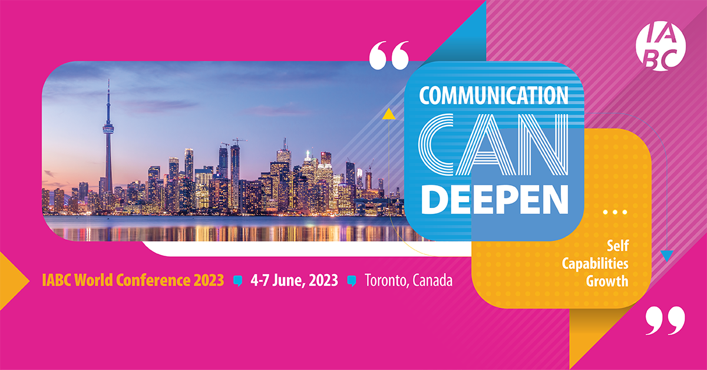

EMAIL:

